Software Design Document
(SDD)

Project Name | HEALTH AI Co-Creation & Innovation Platform
Course | Software Project IV -SENG 384
Group No / Name | Co-Nova EG
Group Members | Gizem Fatma Kılıç -202228028  Ecem Tüysüz -202228050
Submission Date | [22/04/2026]
Version | 1.0
Revision History
Date | Version | Change Description | Author
[21/04/2026] | 1.0 | Initial version

Table of Contents
Table of Contents 2
1. Introduction 3
1.1 Purpose 3
1.2 Scope 3
1.3 Reference Documents 3
1.4 Definitions and Abbreviations 3
2. Architectural Design 3
2.1 Architectural Overview 3
2.2 Layers 3
2.3 Deployment Diagram 3
3. Component Design 3
3.1 Component List 3
3.2 Component Interaction Diagram 4
4. Database Design 4
4.1 ER Diagram 4
4.2 Table Definitions 4
4.2.1 users 4
4.2.2 posts 4
4.2.3 meeting_requests 5
4.2.4 activity_logs 5
5. API Design 5
5.1 Authentication (Auth) 5
5.2 Post Management (Posts) 5
5.3 Meeting Requests (Meetings) 6
5.4 Admin 6
6. UI Design 6
6.1 Screen List and Navigation 6
6.2 Wireframes / Mockups 6
7. Security Design 6
8. State Diagrams 7
8.1 Post Lifecycle 7
8.2 Meeting Request Lifecycle 7
9. SRS–SDD Traceability Matrix 7
10. Appendices (Optional) 7

(Right-click and select “Update Field” in Word to refresh)

1. Introduction

1.1 Purpose

The purpose of this document is to detail the software architecture, system components, and technical design decisions of the "HealthAI Co-Creation Platform" project. It describes how the requirements defined in the SRS document are met at the architectural level.

1.2 Scope

This design covers the frontend (React), backend (Express), and database (SQLite) layers, the Docker-based deployment architecture, and the security protocols required for the platform's operation.

1.3 Reference Documents

Software Requirements Specification (SRS) – HealthAI (v1.0)

Project Brief – HealthAI Platform

1.4 Definitions and Abbreviations

JWT: JSON Web Token (Used for authentication).

REST: Representational State Transfer (Architectural style for the API).

NDA: Non-Disclosure Agreement (Required for project collaborations).

Reverse Proxy: A server (Nginx) that sits in front of web servers and forwards client requests.

2. Architectural Design

2.1 Architectural Overview

The system follows a Decoupled Architecture with a clear separation between the Frontend (React) and Backend (Express) services. The communication is handled via RESTful APIs.

2.2 Layers
Describe the layered structure of the system by filling in the table below.
Layer | Responsibility | Technology Choice
Presentation | Handles the user interface, rendering web pages, and managing global application state through Context API. | React.js(Vite)
Business Logic | Manages JWT-based authentication, request validation, business rules, and RESTful API routing. | Node.js / Express
Data Access | Responsible for database connection management, schema initialization, and executing SQL queries. | JavaScript (database.js)
Database | Provides persistent storage for user data, project posts, meeting requests, and system logs. | SQLite

2.3 Deployment Diagram

The project uses a production-ready Docker architecture:

Nginx Container: Acts as a reverse proxy on Port 80, serving static frontend files and routing /api/ requests to the backend.

Backend Container: A lightweight node:20-alpine image running the Express server.

Data Persistence: A Named Volume (sqlite_data) is mapped to /app/db to prevent data loss when containers are restarted.

3. Component Design
Define the main components (modules/services) of the system and the responsibility of each. Including a component diagram is recommended.

3.1 Component List
Component | Responsibility | Technology / Notes
AuthModule | Manages user registration (restricted to .edu emails), secure login, JWT issuance, and session persistence via AuthContext | React.js (Vite) / JWT
PostModule | Handles full CRUD operations for project posts, lifecycle management (Draft to Closed), and dynamic filtering] | React.js / Node.js
MatchingModule | Facilitates project search and filtering based on user roles and categories using lucide-react for visualization | React.js
MeetingModule | Manages collaboration requests, time proposals, and digital NDA acceptance tracking. | Node.js / Express / SQLite
AdminModule | Provides tools for user suspension, post moderation, and high-level system statistics via AdminDashboard | React.js / Admin role check
AuditModule | Tracks and logs all critical user actions (login, post creation, requests) to the denetim günlüğüne for security | Node.js (database.js) / SQLite
NotificationModule | Handles system-level feedback for actions like successful post creation or received meeting requests | React Context / Express API

3.2 Component Interaction Diagram

React → Makes an API call

Express → Processes the request

Database → Returns data4. Database Design

4.1 ER Diagram
Include an ER diagram showing the relationships between database entities.
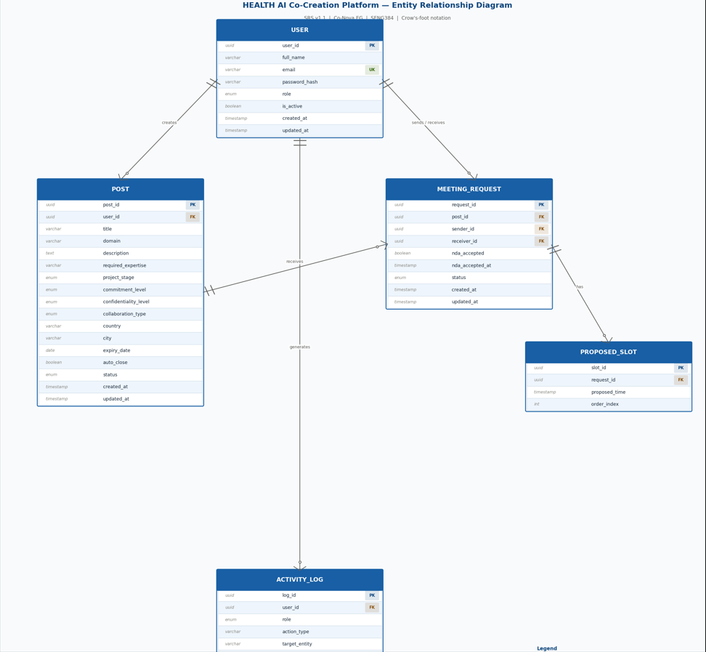

4.2 Table Definitions
Define the fields, data types, and constraints for each table in the format below.

4.2.1 users
Field Name | Data Type | Required | Constraint | Description
id | UUID / INT | Yes | PK | Unique user identifier
email | VARCHAR(255) | Yes | UNIQUE, .edu check | Institutional email
password_hash | VARCHAR(255) | Yes | — | Encrypted password
role | ENUM | Yes | — | engineer / healthcare / admin
is active | BOOLEAN | Yes | DEFAULT TRUE | Indicates whether the account is active or suspended
created_at | TIMESTAP | Yes | DEFAULT CURRENT_TIMESTAMP | Timestamp when the account was created
updated_at | TIMESTAP | No | ON UPDATE CURRENT_TIMESTAMP | Timestamp of the last profile update

4.2.2 posts
Field Name | Data Type | Required | Constraint | Description
id | UUID / INT | Yes | PK | Unique post identifier
user_id | UUID / INT | Yes | FK → users | User who created the post
status | ENUM | Yes | — | draft / active / meeting_scheduled / closed / expired
title | VARCHAR | Yes | -- | Title of the post
domain | VARCHAR | Yes | -- | Domain of the project (e.g., Cardiology Imaging)
description | TEXT | Yes | -- | Detailed explanation of the idea or need
required_expertise | VARCHAR | Yes | -- | Required expertise (e.g., Cardiologist, ML Engineer)
project_stage | ENUM | Yes | -- | Stage of the project (idea, prototype, validation, production)
commitment_level | ENUM | Yes | -- | Expected commitment (advisor, part-time, full-time)
confidentiality_level | ENUM | Yes | -- | Confidentiality level (public, NDA_required)
collaboration_type | ENUM | Yes | -- | Type of collaboration (research, startup, consulting)
country | VARCHAR | Yes | -- | Country where the project is based
city | VARCHAR | Yes | -- | City where the project is based
expiry_date | DATE | Yes | -- | Expiration date of the post
auto_close | BOOELAN | Yes | DEFAULT FALSE | If true, the post is automatically closed when a meeting is scheduled
created_at | TIMESTAMP | Yes | DEFAULT CURRENT_TIMESTAMP | Post creation time
updated_at | TIMESTAMP | Yes | ON UPDATE CURRENT_TIMESTAMP | Last update time

4.2.3 meeting_requests
Field Name | Data Type | Required | Constraint | Description
id | UUID / INT | Yes | PK | Meeting request identifier
post_id | UUID / INT | Yes | FK → posts | Related post
requester_id | UUID / INT | Yes | FK → users | Requesting user
receiver_id | UUID / INT | Yes | FK->users | User who receives the request (post owner)
nda_accepted | BOOELAN | Yes | DEFAULT FALSE | Indicates whether NDA is accepted
nda_accepted_at | TIMESTAP | No | -- | Timestamp when NDA was accepted
status | ENUM(Pending, Accepted, Rejected, Canceled) | Yes | -- | Request status (pending, accepted, rejected, scheduled, canceled)
created_at | TIMESTAP | Yes | DEFAULT CURRENT_TIMESTAMP | Request creation time
updated_at | TIMESTAP | Yes | ON UPDATE CURRENT_TIMESTAMP | Last update time

4.2.4 activity_logs
Field Name | Data Type | Required | Constraint | Description
id | UUID / INT | Yes | PK | Log entry identifier
user_id | UUID / INT | Yes | FK → users | User who performed the action
action_type | VARCHAR(100) | Yes | — | login / post_create / meeting_request / ...
role | ENUM | Yes | NOT NULL | Role of the user at the time of action (Engineer, HealthcareProfessional, Admin)
target_entity | VARCHAR | No | -- | Entity affected by the action (e.g., post, meeting_request, user)
target_id | UUID | No | -- | ID of the affected entity
timestamp | TIMESTAMP | Yes | DEFAULT CURRENT_TIMESTAMP | Time when the action occurred
result_status | VARCHAR | Yes | -- | Result of the action (success, failed)
ip-address | VARCHAR | No | -- | IP address of the user (for security tracking)
Must be consistent with the data model in your SRS. Add additional tables (notifications, nda_acceptances, etc.) as needed.

5. API Design
Define the backend API endpoints in RESTful format. For each endpoint, specify the HTTP method, URL, description, required authorization, and SRS requirement reference.

5.1 Authentication (Auth)
Method | Endpoint | Description | Auth | SRS Ref.
POST | /api/auth/register | New user registration | Public | FR-01
POST | /api/auth/login | User login | Public | FR-02
POST | /api/auth/verify-email | Email verification | Public | FR-02
POST | /api/auth/logout | End session | Authenticated | —

5.2 Post Management (Posts)
Method | Endpoint | Description | Auth | SRS Ref.
GET | /api/posts | List all posts (with filters) | Authenticated | FR-20
POST | /api/posts | Create a new post | Authenticated | FR-10
GET | /api/posts/:id | Get post details | Authenticated | —
PUT | /api/posts/:id | Update a post | Owner | FR-11
PATCH | /api/posts/:id/status | Change post status | Owner | FR-12
Create similar tables for other modules: Meeting, Admin, Log endpoints.

5.3 Meeting Requests (Meetings)
Method | Endpoint | Description | Auth | SRS Ref.
POST | /api/meetings | Send a meeting request | Authenticated | FR-30
GET | /api/meetings/incoming | Get incoming requests | Authenticated | FR-27
GET | /api/meetings/outgoing | Get outgoing requests | Authenticated | FR-27
PATCH | /api/meetings/:id/accept | Accept request | Authenticated | FR-28
PATCH | /api/meetings/:id/cancel | Cancel request | Authenticated | FR-29

5.4 Admin
Method | Endpoint | Description | Auth | SRS Ref.
GET | /api/admin/users | List all users | Admin | FR-40
PATCH | /api/admin/users/:id | Suspend user | Admin | FR-07
GET | /api/admin/posts | View all posts | Admin | FR-33
DELETE | /api/admin/posts/:id | Remove post | Admin | FR-34
GET | /api/admin/logs | View logs | Admin | FR-48
GET | /api/admin/stats | Platform stats | Admin | FR-38

6. UI Design

6.1 Screen List and Navigation
List the main screens and describe the transitions between them. Including a navigation flow diagram is recommended.
Screen | Description | Access
Registration / Login | Allows users to create an account using institutional (.edu) email or log in to the platform. Includes authentication and validation mechanisms. | Public
Dashboard | Main landing page after login. Displays posts based on user role (Engineer sees clinical needs, Healthcare Professional sees engineers). Includes filtering and navigation options. | Authenticated
Create Post | Multi-step form that allows healthcare professionals to create a new project post including basic info, requirements, and configuration settings. | Authenticated
Post Detail | Displays full details of a selected post including description, required expertise, and project information. Allows users to send meeting requests. | Authenticated
Meeting Request | Interface for sending a collaboration request. Includes introductory message and NDA acceptance before submission. | Authenticated
Incoming Requests | Shows meeting requests received by the user. Allows accepting, rejecting, or scheduling a meeting. | Authenticated
Outgoing Requests | Displays requests sent by the user and their current status (pending, accepted, scheduled, rejected) | Authenticated
My Announcements | Lists posts created by the user. Allows editing, archiving, or marking a partner as found. | Authenticated
Edit Announcement | Allows users to update an existing post’s details and configuration. | Authenticated
Propose Time Modal | Popup interface for proposing a meeting time and adding meeting link after accepting a request. | Authenticated
Account Settings | Allows users to update profile information (name, university, domain). Email and role are read-only. Includes account export and deletion options. | Authenticated
Admin Panel | Provides administrative controls such as managing users, posts, logs, and system statistics. | Admin

6.2 Wireframes / Mockups
Include wireframes or mockups for at least 3–4 key screens. You can use hand drawings, Figma, Balsamiq, or similar tools. Suggested screens: Registration page, Dashboard (post list), Post creation form, Post detail + meeting request.

Example Pages : Landing , Sign in ,Registeration , Dashboard , Post Creation(Step 1) , Incoming Request Pages
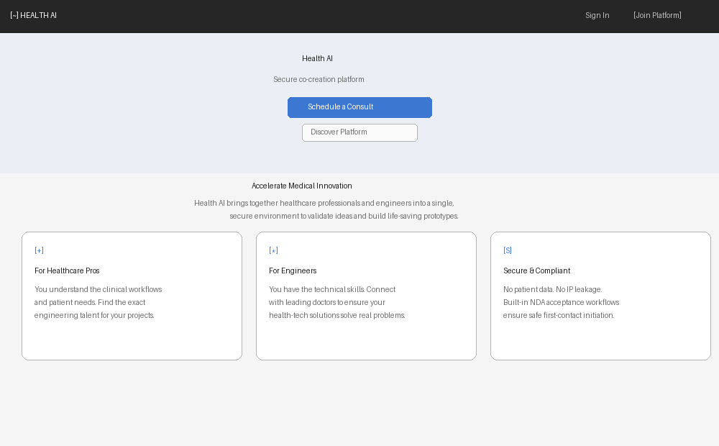
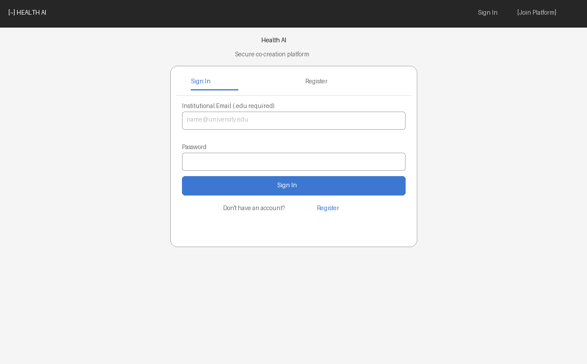
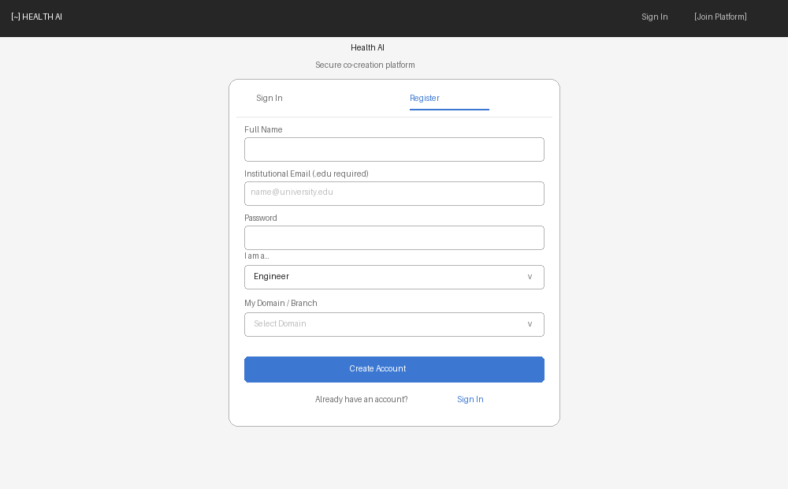
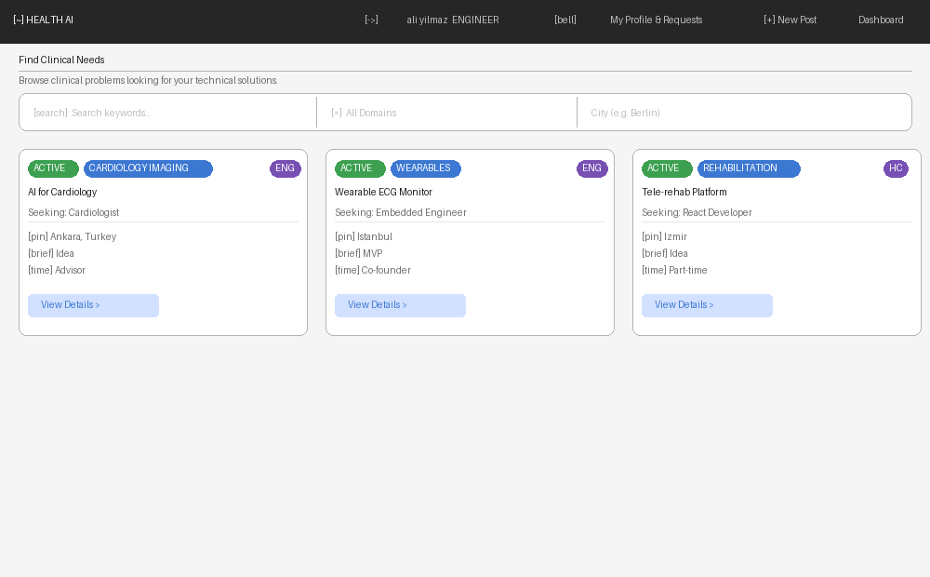
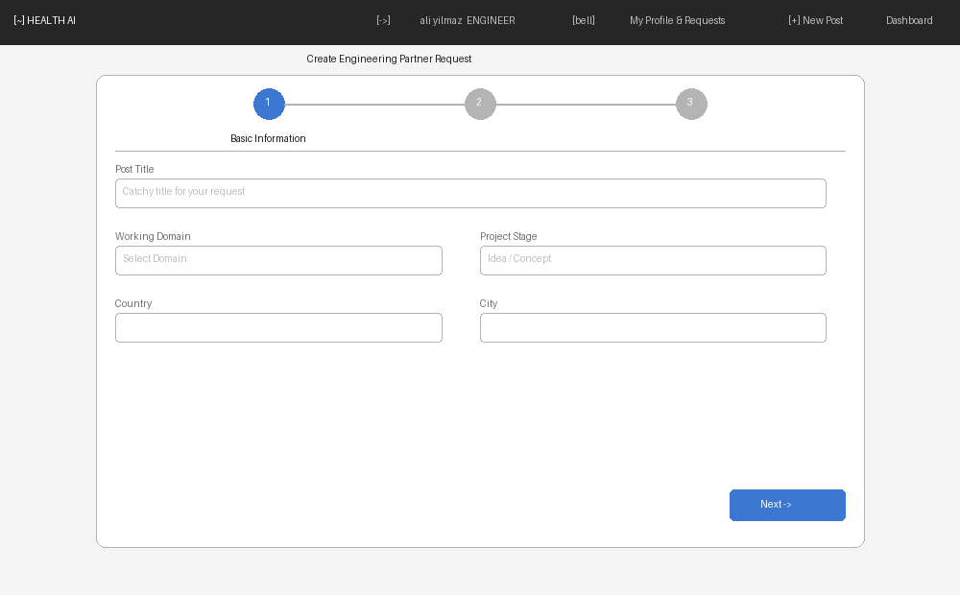
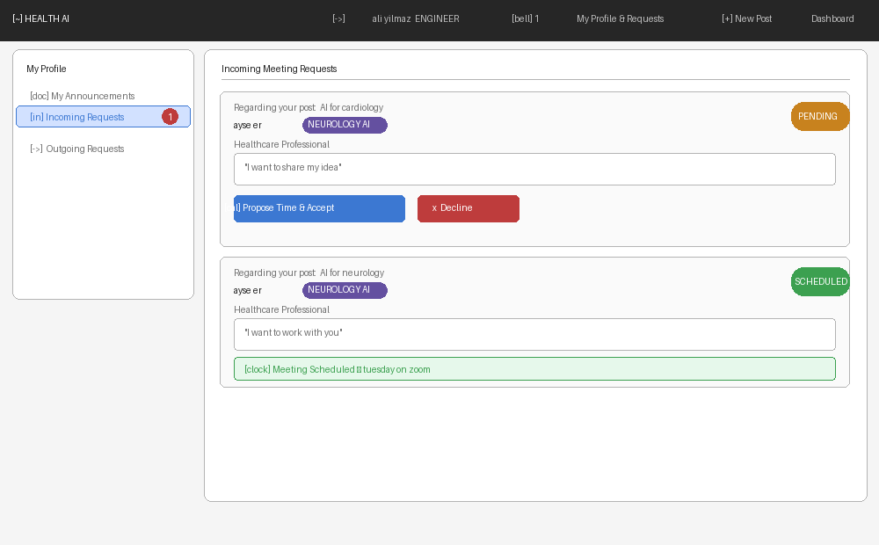

7. Security Design
Security Requirement | Design Decision | SRS Ref.
Authentication | JWT-based authentication | FR-06, NFR-04
Password storage | bcrypt hashing | NFR-05
Authorization (RBAC) | Role-Based Access Control (RBAC) | FR-03
Session management | Token-based sessions | NFR-06
GDPR compliance | -Data export (NFR-11)  -Account deletion (NFR-10)  -No patient data stored (NFR-12) | NFR-11  NFR-10  NFR-12
Rate limiting | Basic API protection | NFR-xx
NDA Enforcement | Required before meeting request | FR-25
HTTPS | All communications secured | NFR-04

8. State Diagrams

8.1 Post Lifecycle
Draft → Active | User clicks "Publish”
Active → Meeting Scheduled | Request accepted
Meeting Scheduled → Partner Found | User confirms partner
Active → Expired | Expiry date reached

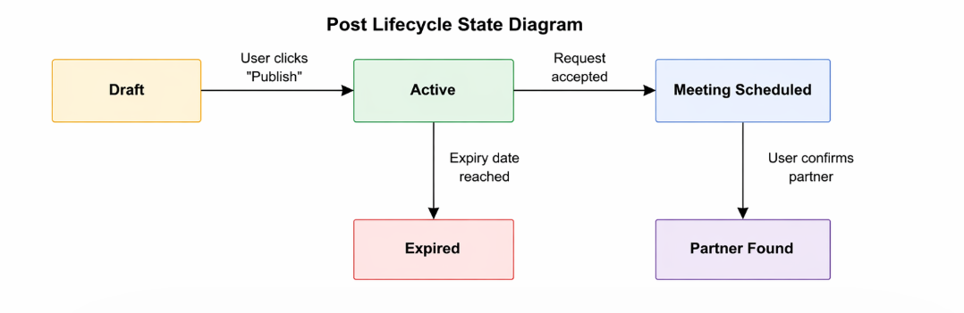8.2 Meeting Request Lifecycle
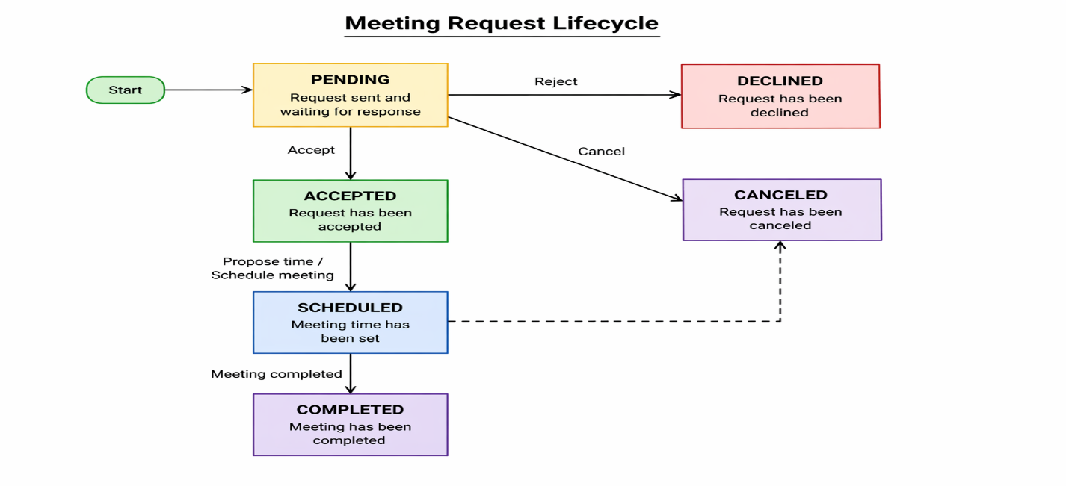

9. SRS–SDD Traceability Matrix
Show which SDD section/component/API addresses each SRS requirement. Ensure all functional requirements are covered.
SRS Ref. | Requirement Summary | SDD Component | SDD Section
FR-01 | .edu email restriction | AuthModule | Section 3.1, 5.1
FR-10 | Post creation | PostModule | Section 3.1, 5.2
FR-24 | MeetingModule | MeetingModule | API: /api/meetings
FR-32 | Admin Module | Admin Module | API: /api/admin/*
FR-39 | Audit Module | Audit Module | activity_logs table

